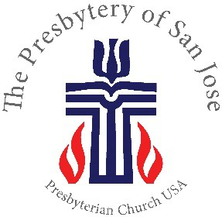
The Rev. Joseph S. Lee, Executive Presbyter
joey@sanjosepby.org

The Rev. Erica Rader, Stated Clerk
erica@sanjosepby.org

890 Meridian Way, San Jose CA 95126-3856 Phone: (408) 279-0220 ▪ Fax: (408) 279-5261
Email: info@sanjosepby.org ▪ Website: www.sanjosepby.org

Presbytery of San Jose At-Large Clergy Information Form

Name |  |  | Date:
Home Address |  |  | Name of spouse/partner (if applicable)
Home Phone |  |  | Name of child(ren) (if applicable)
Employer
Position
Work Phone
Email

- Where do you regularly worship?

- Are you a Parish Associate? No Yes, at: Did the Session affirm your Parish Associate status for this year? Yes No
____
____
___
___

- When did you last take the Presbytery's mandated safe church or GPS training? (Month/Year)

- Are you currently serving in a validated ministry? Yes No
___
___
If yes, when was the last time Presbytery reviewed your validated position? (Month/Year)

- Are you currently serving in a position that you would like us to consider validating? Yes No
___
___

- If you answered “Yes” to question 4 or 5, please provide the following information:

  - Position/Employer:

  - Duties:

Page 1

  - “Effective Salary” (salary + housing + other cash benefits): _

  - If you are not a Board of Pensions member, do you have health insurance? Yes No
___
___

- At ordination, we promised to “be active in government, serving in the governing bodies of the Church.” How have you been involved in Presbytery, Synod, or General Assembly activities?
- What other Presbytery, Synod, or General Assembly activities are you interested in participating in, if any?

- Are you willing to be considered for occasional guest preaching opportunities? Yes No
___
___

- Are you willing to be considered for interim/pulpit supply/temporary supply opportunities?

Yes No
___
___

- Please let us know how we could best provide support to you:

- Do you have any other needs, comments or suggestions?

